TABLE OF CONTENTS

Introduction

Data Source

Analysis questions

Approach

Analysis

Visualization

Conclusion

Introduction

This project is based on covid-19 cases in Nigeria. Covid-19 broke out in late 2019 and spread across countries and continents. This resulted to loss of lives and halted the global economy that led many countries to recessions and kept health workers on their feet. Therefore, immediate approach is required to tackle the deadly pandemic. And analysis is required to know the spread and approach required.

Data Source

To carry out the analysis, I scrapped raw data from NCDC website using BeautifulSoup and external data from john Hopkins repository. Then I cleaned the data and make it ready for the analysis.

urllib.request, BeautifulSoup and other tools were imported from python library to scrape data.

About the Analysis

The purpose of the analysis is to know the confirmed cases, the recovered cases and the death covid_19 cases. Nigeria was used as case study.

The analysis was conducted in other to find out the most affected States in Nigeria. With the help of the analysis we can make recommendation and or prediction of how to tackle the case.

Summary of analysis questions

Extracting daily cases for Nigeria from Global Dataset on covid_19

I merged the extracted dataset of daily confirmed cases, recovered cases and death cases to form a dataFrame. Reset index of the new dataframe.

The following questions was asked to come up with the analysis:

* Get a Pandas DataFrame for Daily Confirmed Cases in Nigeria. Columns are Date and Cases
* Get a Pandas DataFrame for Daily Recovered Cases in Nigeria. Columns are Date and Cases
* Get a Pandas DataFrame for Daily Death Cases in Nigeria. Columns are Date and Cases
* Generate a plot that shows the Top 10 states in terms of Confirmed Covid cases by Laboratory test
* Generate a plot that shows the Top 10 states in terms of Discharged Covid cases. Hint - Sort the values
* Generate a Plot that shows the top 10 Death cases
* Generate a line plot for the total daily confirmed, recovered and death cases in Nigeria
* Determine the daily infection rate, you can use the Pandas diff method to find the derivate of the total cases.
* Calculate maximum infection rate for a day (Number of new cases)
* Find the date.
* Determine the relationship between the external dataset and the NCDC COVID-19 dataset.
* Determine the relationship between the external dataset and the NCDC COVID-19 dataset.
* Determine the effect of the Pandemic on the economy. To do this, you will compare the Real GDP value Pre-COVID-19 with Real GDP in 2020 (COVID-19 Period, especially Q2 2020).
* Determine which states has high rated health system

Approach

I carried out the analysis using the available data provided by NCDC and external data from website. I scrapped the raw data from the web using BeautifulSoup library in python and other libraries available, also import some data from john Hopkins repository.

I cleaned up the data, and charted it for the analysis.

Analysis

Analysis was done answering the analysis question above. This analysis was done in other to identify the causes of the pandemic and how it spread across the countries. Also to know its effect in the economy.

Therefore, Nigeria covid-19 case was extracted from global covid-19 cases Dataset. With the analysis, I was able to find out the state affected with the cases and the total number of cases recorded. Which includes total confirmed cases, recovered cases and death cases across all the states in the country.

Visualization

I visualized 10 most State with high number of Cases lab Confirmed as shown in the chart below.

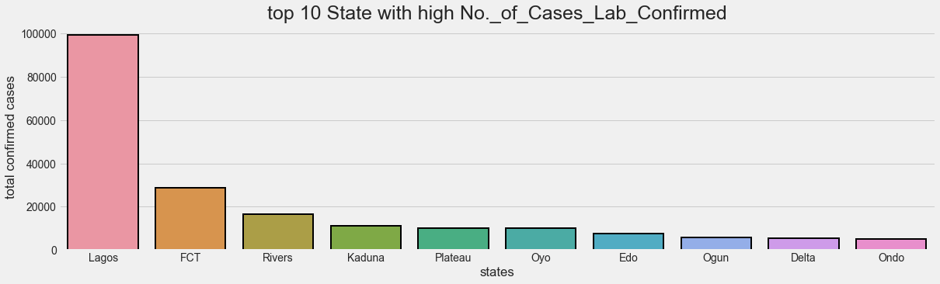

I visualized the result of the analysis of 10 states with most discharged covid_19 cases 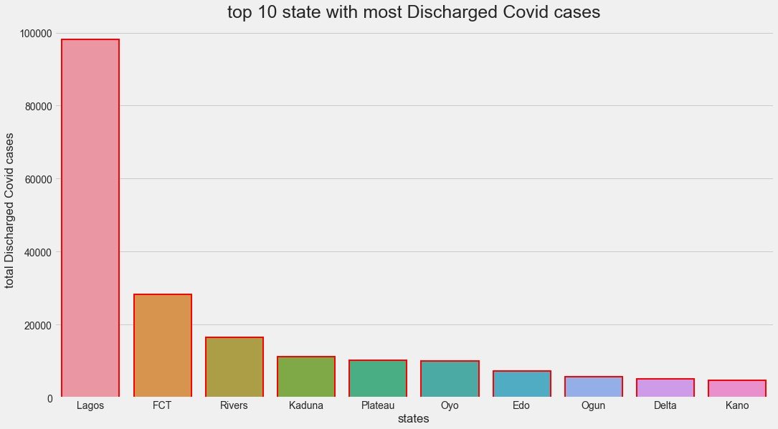

I generated a line plot for the total daily confirmed, recovered and death cases in Nigeria

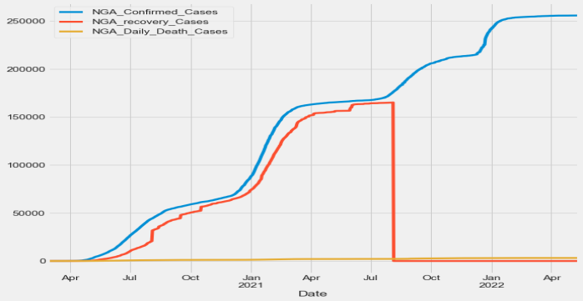

i generated a regression plot between two variables to visualize the linear relationships - Confirmed Cases and Population Density.

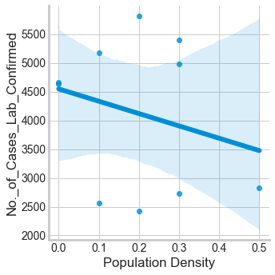

In conclusion

covid-19 was a viral disease that hit the world and both people and economy of the world is affected. This lead to the analysis carried out on country “Nigeria” to know how hard it hit the country’s people and economy. Also to know how it was handle.

Out of 37 States in the country, the most affected were just few and the highest number affection figure was within range of 10000 and death case in range of 750-800. and it affected the gdp of the country in the second and last quarter of 2020.